**Lab # 02**

**Lab Tasks:**

**Task #1: Write a program that initializes Vector with 10 integers in it. Display all the integers and sum of these integers**

**Code:**

package dsa_lab;

import java.util.Vector;

public class DSA_Lab_2 {

public static void main(String[] args) {

Vector<Integer> vec1=new Vector<Integer>(10);

int n=6;

for(int i=0;i<10;i++){

vec1.add(n);

n=n+5;

}

System.out.print("Vector: ");

System.out.print(vec1);

int sum=vec1.stream().mapToInt(Integer::intValue).sum();

System.out.println("\nSum of members: "+sum);

}

}

**Output:**

**Task #2:** **Create a ArrayList of string. Write a menu driven program which:**

**a. Displays all the elements**

**b. Displays the largest String**

**Code:**

package dsa_lab;

import java.util.*;

public class DSA_Lab_2 {

public static void main(String[] args) {

//Task #2

ArrayList<String> ar1 = new ArrayList<String>();

Scanner sc = new Scanner(System.in);

int choice;

System.out.println("Enter five menu Items:");

for (int i = 0; i < 5; i++) {

ar1.add(sc.nextLine());

}

do {

System.out.println("\nMenu:");

System.out.println("1. Display all items");

System.out.println("2. Display the largest item");

System.out.println("3. Exit");

System.out.print("Enter your choice: ");

choice = sc.nextInt();

sc.nextLine();

switch (choice) {

case 1:

System.out.print("Menu Display:");

for (String e : ar1) {

System.out.println(item);

}

break;

case 2:

String largest = " ";

for (String item : ar1) {

if (item.length() > largest.length()) {

largest = item;

}

}

System.out.println("Largest Item: " + largest);

break;

case 3:

System.out.println("Exiting program.");

break;

default:

System.out.println("Invalid choice. Please try again.");

}

}

while (choice != 3);

sc.close();

}

}

}

**Output:**

**Task #3: Create a Arraylist storing Employee details including Emp_id, Emp_Name, Emp_gender, Year_of_Joining (you can also add more attributes including these). Then sort the employees according to their joining year using Comparator and Comparable interfaces.**

**Code:**

package dsa_lab;

import java.util.*;

//Task #3

class Employee implements Comparable<Employee> {

private String name;

private String gender;

private int id;

private int yearOfJoining;

public Employee(int id, String name, int yearOfJoining, String gender) {

this.name = name;

this.gender = gender;

this.yearOfJoining = yearOfJoining;

this.id = id;

}

public int getYearOfJoining() {

return yearOfJoining;

}

@Override

public int compareTo(Employee other) {

// Ascending order by year of joining

return this.yearOfJoining - other.yearOfJoining;

}

@Override

public String toString() {

return "ID: " + id + ", Name: " + name + ", Gender: " + gender + ", Year of Joining: " + yearOfJoining;

}

// Comparator for sorting by year of joining in descending order

public static Comparator<Employee> YearDescendingComparator = new Comparator<Employee>() {

@Override

public int compare(Employee e1, Employee e2) {

return e2.getYearOfJoining() - e1.getYearOfJoining();

}

};

public static void main(String[] args) {

ArrayList<Employee> employees = new ArrayList<>();

employees.add(new Employee(103, "Hassan", 2020, "Male"));

employees.add(new Employee(180, "Jameel", 2024, "Male"));

employees.add(new Employee(150, "Aisha", 2019, "Female"));

employees.add(new Employee(80, "Zia", 2009, "Male"));

// Sorting employees by year of joining in ascending order (Comparable)

Collections.sort(employees);

System.out.println("Employees sorted by year of joining (ascending):");

for (Employee employee : employees) {

System.out.println(employee);

}

// Sorting employees by year of joining in descending order (Comparator)

Collections.sort(employees, Employee.YearDescendingComparator);

System.out.println("\nEmployees sorted by year of joining (descending):");

for (Employee employee : employees) {

System.out.println(employee);

}

}

}

**Output:**

**Task #4: Write a program that initializes Vector with 10 integers in it.**

**• Display all the integers**

**• Sum of these integers.**

**• Find Maximum Element in Vector**

**Code:**

package dsa_lab;

import java.util.*;

public class DSA_Lab_2 {

public static void main(String[] args) {

//Task #4

Vector<Integer> vec2=new Vector<Integer>(10);

//Initializing value

int n=6;

for(int i=0;i<10;i++){

vec2.add(n);

n=n+5;

}

System.out.print("Vector: ");

System.out.print(vec2);

System.out.println();

//Calculate sum and max value

int sum=0;

int max=0;

for(int c:vec2){

if(c>max){

max=c;

}

sum+=c;

}

System.out.println("Sum is: "+sum);

System.out.println("Max Value is: "+max);

}

}

**Output:**

**Task #5: Find the k-th smallest element in a sorted ArrayList**

**Code:**

package dsa_lab;

import java.util.Vector;

public class DSA_Lab_2 {

public static void main(String[] args) {

ArrayList<Integer> ark = new ArrayList<>();

Scanner sc = new Scanner(System.in);

System.out.println("Enter values for a Sorted ArrayList (non-integer to stop):");

while (sc.hasNextInt()) {

ark.add(sc.nextInt());

}

System.out.println("Enter k (position for k-th smallest value):");

int k = 5;

// Sorting ArrayList

Collections.sort(ark);

if (k > 0 && k <= ark.size()) { // Adjust condition to include the last element

int kthSmallest = ark.get(k - 1); // k-1 to access k-th element correctly

System.out.println("The smallest of " + k + "-th value is: " + kthSmallest);

} else {

System.out.println("k must be between 1 and " + ark.size());

}

}

}

**Output:**

**Task #6: W** **rite a program to merge two ArrayLists into one.**

**Code:**

package dsa_lab;

import java.util.Vector;

public class DSA_Lab_2 {

public static void main(String[] args) {

ArrayList<Integer> m1=new ArrayList<Integer>();

m1.add(20);

m1.add(59);

m1.add(93);

ArrayList<Integer> m2=new ArrayList<Integer>();

m2.add(89);

m2.add(30);

ArrayList<Integer> merged=new ArrayList<Integer>();

merged.addAll(m1);

merged.addAll(m2);

System.out.println("1st ArrayList: "+m1);

System.out.println("2nd ArrayList: "+m2);

System.out.println("Merged ArrayList: "+merged);

Collections.sort(merged);

System.out.println( "Sorted Merged ArrayList: "+merged); }

}

**Output:**

**Home Tasks:**

**Task #1: Create a Vector storing integer objects as an input.**

* **Sort the vector**
* **Display largest number**
* **Display smallest number**

**Code:**

public class Dsa_Lab2_HomeT {

public static void main(String[] agrs){

/*Vector<Integer> vect=new Vector<Integer>();

Scanner sc=new Scanner(System.in);

System.out.println("Enter 10 integers: ");

//Adding Integer

for(int i=0;i<10;i++){

vect.add(sc.nextInt());

}

System.out.print("\nVector: ");

for(int i:vect){

System.out.print(i+" ");

}

System.out.print("\nSorted Vector: ");

Collections.sort(vect);

for(int i:vect){

System.out.print(i+" ");

}

//Since Vector is Sorted

System.out.print("\nLargest Integer: ");

System.out.println(vect.getLast());

System.out.print("Smallest Integer: ");

System.out.println(vect.getFirst());

}

}

**Output:**

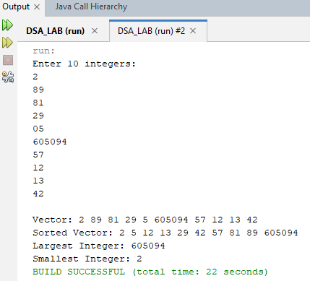

**Task #2: Write a java program which takes user input and gives hashcode value of those inputs using hashCode () method.**

**Code:**

public class Dsa_Lab2_HomeT {

public static void main(String[] agrs){

Scanner scanner = new Scanner(System.in);

System.out.print("Enter a string to get its hash code (or type 'exit' to quit): ");

String input = scanner.nextLine();

while (!input.equalsIgnoreCase("exit")) {

int hashCode = input.hashCode();

System.out.println("Hash code of \"" + input + "\": " + hashCode);

System.out.print("Enter another string (or type 'exit' to quit): ");

input = scanner.nextLine();

}

System.out.println("Program exited.");

scanner.close();

}

}

**Output:**

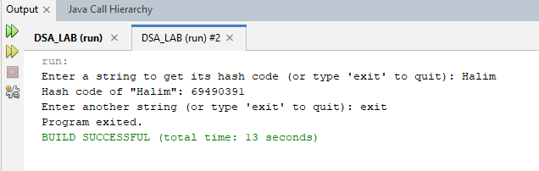

**Task #3: Scenario based Create a java project, suppose you work for a company that needs to manage a list of employees. Each employee has a unique combination of a name and an ID. Your goal is to ensure that you can track employees effectively and avoid duplicate entries in your system.**

**Requirements**

* **Employee Class: You need to create an Employee class that includes:**
* **name: The employee's name (String).**
* **id: The employee's unique identifier (int).**
* **Override the hashCode() and equals() methods to ensure that two employees are considered equal if they have the same name and id.**

**b) Employee Management: You will use a HashSet to store employee records. This will help you avoid duplicate entries.**

**c) Operations: Implement operations to:**

* **Add new employees to the record.**
* **Check if an employee already exists in the records.**
* **Display all employees.**

**Code:**

package dsa_lab;

import java.util.*;

class Employee {

private String name;

private int id;

public Employee(String name, int id) {

this.name = name;

this.id = id;

}

@Override

public int hashCode() {

int result = 11;

result =/*Prime No*/ 31 * result/*11*/ + name.hashCode();

result =/*Prime No*/ 31 * result/*11*/ + id;

return result;

}

@Override

public boolean equals(Object o) {

if (this == o) {

return true;

}

if (o == null || getClass() != o.getClass()) {

return false;

}

Employee e = (Employee) o;

return id == e.id && name.equals(e.name);

}

@Override

public String toString() {

return "Employee: {Name: " + name + " Id: " + id + "}";

}

}

class EmployeeManagement {

private HashSet<Employee> hse;

public EmployeeManagement() {

hse = new HashSet<>();

}

public boolean addEmployee(Employee emp) {

if (hse.contains(emp)) {

System.out.println("Employee already exists: " + emp);

return false;

} else {

hse.add(emp);

System.out.println("Employee added: " + emp);

return true;

}

}

public boolean employeeExists(Employee employee) {

return hse.contains(employee);

}

// Display all employees

public void displayAllEmployees() {

if (hse.isEmpty()) {

System.out.println("No employees found.");

} else {

System.out.println("Employee Records:");

for (Employee emp : hse) {

System.out.println(emp);

}

}

}

}

public class HomeTaskEmployee {

public static void main(String[] args) {

EmployeeManagement em = new EmployeeManagement();

Scanner sc = new Scanner(System.in);

while (true) {

System.out.println("Select an Option:");

System.out.println("1) Add an Employee:");

System.out.println("2) Check Employee");

System.out.println("3) Display all");

System.out.println("4) Exit \n");

int choice = sc.nextInt();

switch (choice) {

case 1:

System.out.print("Enter Name: ");

String n = sc.nextLine(); // Corrected: properly captures name

System.out.print("Enter Id: ");

int i = sc.nextInt();

sc.nextLine(); // Consume newline after integer input

Employee emp = new Employee(n, i);

em.addEmployee(emp);

break;

case 2:

System.out.print("Enter Name: ");

String na = sc.nextLine();

System.out.print("Enter Id: ");

int id = sc.nextInt();

sc.nextLine(); // Consume newline after integer input

Employee empl = new Employee(na, id);

if (em.employeeExists(empl)) {

System.out.println("Employee exists: " + empl);

} else {

System.out.println("Employee not found.");

}

break;

case 3:

em.displayAllEmployees();

break;

case 4:

System.out.println("Exiting Program");

sc.close();

return;

default:

System.out.println("Invalid Choice");

break;

}

}

}

}

**Output:**

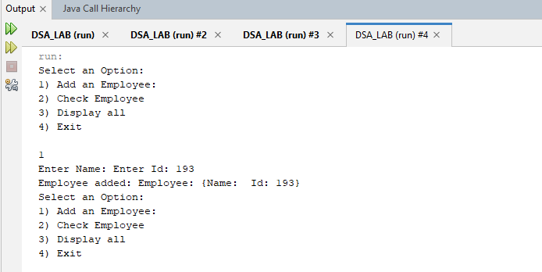

**Task#4:Create a Color class that has red, green, and blue values. Two colors are considered equal if their RGB values are the same**

**Code:**

package dsa_lab;

class Color{

private int red;

private int green;

private int blue;

public Color(int r,int g,int b ){

red=r;

green=g;

blue=b;

}

@Override

public int hashCode(){

int result=31*red+31*green+31*blue;

return result;

}

@Override

public boolean equals(Object obj){

if(this==obj)return true;

if(obj==null||getClass()!=obj.getClass())return false;

Color c=(Color) obj;

return red==c.red &&green==c.green&& blue==c.blue;

}

@Override

public String toString() {

return "Color{red=" + red + ", green=" + green + ", blue=" + blue + "}";

}

}

public class HomeTaskColor {

public static void main(String[] args ){

Color c1=new Color(250,0,90);

Color c2=new Color(250,0,0);

Color c3=new Color(250,0,0);

System.out.println("c1 compare to c2:"+c1.equals(c2));

System.out.println("c2 compare to c3:"+c2.equals(c3));

System.out.println("color1 hashCode: " + c1.hashCode());

System.out.println("color2 hashCode: " + c2.hashCode());

System.out.println("color3 says " + c3.toString());

}

}

**Output:**

